Project Readme file

1. First download the github file, then install all dependencies by typing “npm install " in terminal.
2. Then run the NextJs project by " npm run dev "
3. Open [http://localhost:3000](http://localhost:3000) with your browser to see the result.



1. On clicking Ecommerce icon it will navigate back to the home page.
2. On clicking About us it will navigate to the About page.
3. On clicking Products it will navigate to the all products page.
4. On clicking Contact us page a form will be opened fill it to save response on database.
5. On clicking on Sign in page you will redirect to login page or you can sign up from there if you are a new user.

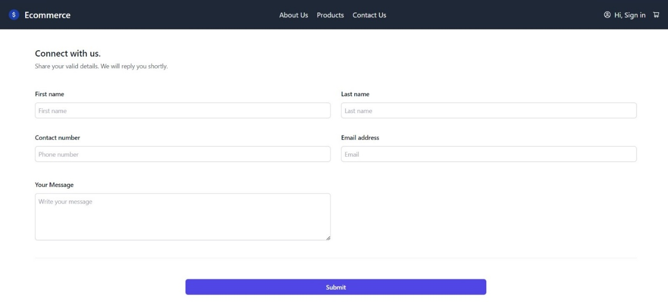

1. Here fill all the details correctly.
2. On submitting your response will be saved in database.
3. I have used firebase for saving the data.

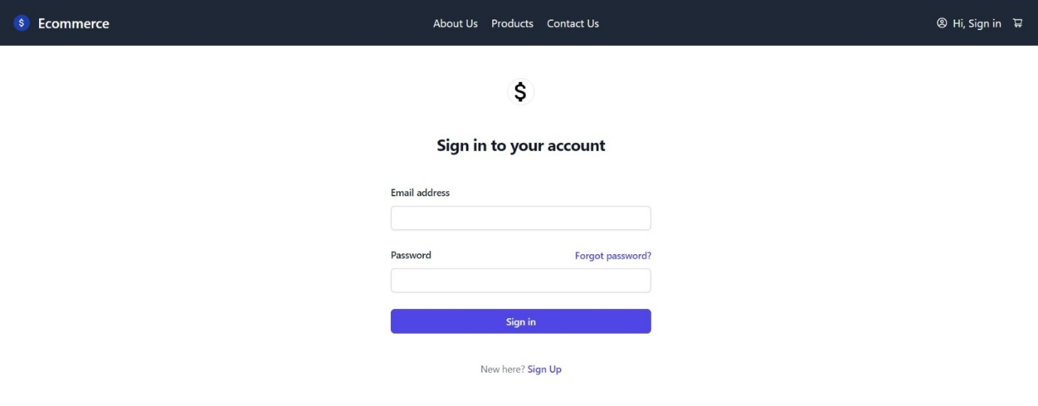

1. Here you can sign in if you have Sign up already.
2. Otherwise go to sign Up option at the bottom to signh up.
3. Beware password must be of { 8 digits }.

At last, This website may contain many bug as I don’t have much time to complete it and it may be incomplete at some place.

I can definitely make it industry ready if I have sufficient time.

Thank you for this opportunity .